Mark Pratt

CST-247

8/6/2020

Professor Pritchard

Activity 4 Screenshots

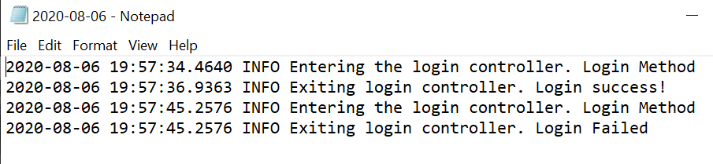

Screenshot 1 and 2

Screenshot showing the log for both success and failed logins

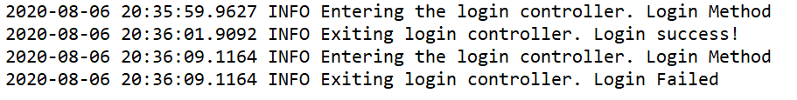

Screenshot 3 and 4

Screenshot shows log for successful and unsuccessful logins after implementing ILogger

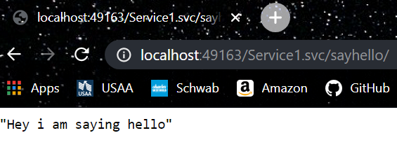

Screenshot 5

Say Hello

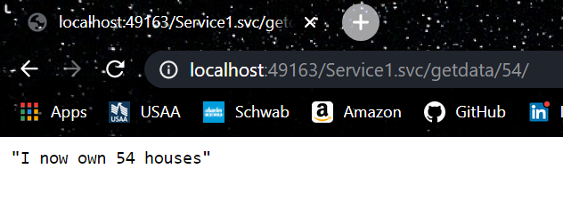

Screenshot 6

Get Data

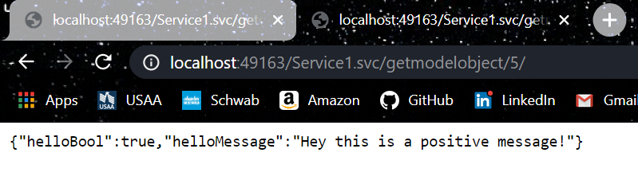

Screenshot 7

Get Model Object

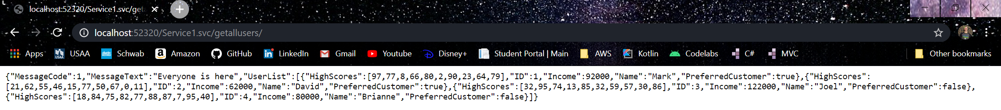

Screenshot 8

Get All Users DTO function

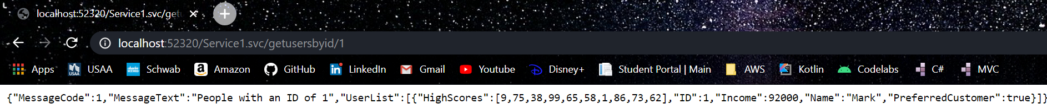

Screenshot 9

Get user / 1

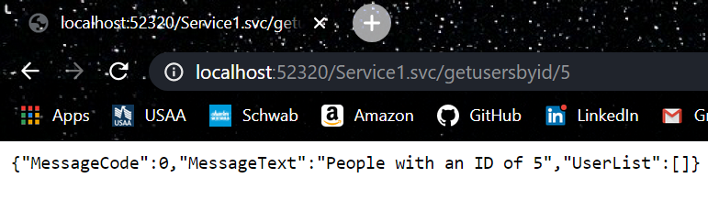

Screenshot 10

Get user / 5 -> number greater than list of users